Sustainability and performance evaluation after assembling a low-cost portable freezer

Akib Muhammad  
*dept. Computer Science &Engineering*   
*American International University of Bangladesh (AIUB)*Dhaka, Bangladesh  
19-39372-1@student.aiub.edu

Shanjida Islam Labonno  
*dept. Computer Science &Engineering*   
*American International University of Bangladesh (AIUB)*Dhaka, Bangladesh  
 20-42958-1@student.aiub.edu

Tahseen Asma Meem  
*Assistant Prof., dept. Electrical & Electronic Engineering*   
*American International University of Bangladesh (AIUB)*Dhaka, Bangladesh  
 tahseen@aiub.edu

Md. Tahmid Ashraf Chowdhury  
*dept. Computer Science &Engineering*   
*American International University of Bangladesh (AIUB)*Dhaka, Bangladesh  
 20-43001-1@student.aiub.edu

Kazi Md, Towhidul Alam  
*dept. Computer Science &Engineering*   
*American International University of Bangladesh (AIUB)*Dhaka, Bangladesh  
 20-42979-1@student.aiub.edu

Shahidul Islam Ifte  
*dept. Computer Science &Engineering*   
*American International University of Bangladesh (AIUB)*Dhaka, Bangladesh  
 20-42088-1@student.aiub.edu

Esha Saha Puja  
*dept. Computer Science &Engineering*   
*American International University of Bangladesh (AIUB)*Dhaka, Bangladesh  
 18-37441-1@student.aiub.edu

*Abstract*—Refrigerators are regarded as essential household items that fall under the category of cooling devices. The refrigerator's basic design consists of a thermally insulated compartment that, with the help of the proper component, lowers the temperature inside and radiates heat outside. It is used to keep and store food, and beverages that can spoil at ambient temperature because it maintains a lower temperature. There are refrigerators of every size available on the market, but they are only suitable for indoor use because they are large and require high power consumption. However, people are becoming increasingly interested in outdoor adventures and vacations, and they need to have a refrigerator to keep the essential food, beverages, and water safe from degradation and waste. As a result, this initiative was to design a small fridge that is powered by batteries and is adaptable enough to be used outside.

Keywords—embedded system, portable, freezer, thermos cooler, temperature, pristine food, and beverages.

# Introduction

## Background of Study and Motivation:

A portable fridge is a self-contained storage unit that regulates its internal temperature using an external power source. A portable fridge doesn't use ice or freezer packs to keep its contents cool, unlike a conventional cooler. A portable freezer comes in handy so much in outdoor adventure. People can’t bring their home fridge outdoors. So, a portable freezer can get them fresh food or beverage outdoors. A typical cooler can contain fresh food for a maximum of one day but a portable freezer can keep foods or beverages fresh and cool for a few days which is so useful during vacations. Thus a portable freezer is easy to use and new smart technologies can ease the exhaustion from the extremely humid environment.

*Survey questionnaire and response:*

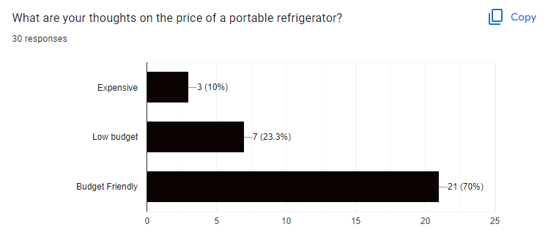

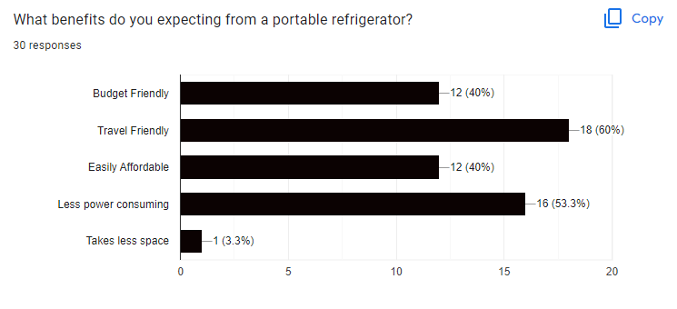

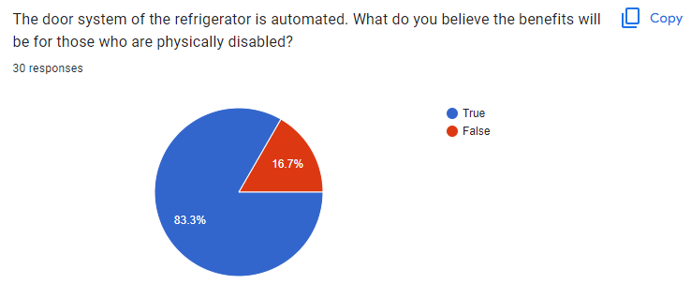

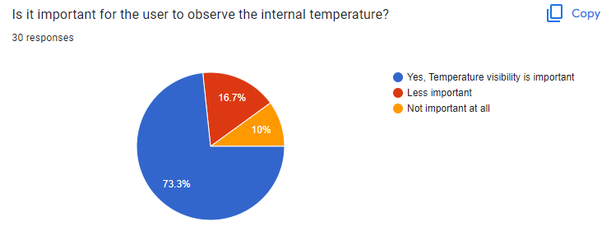

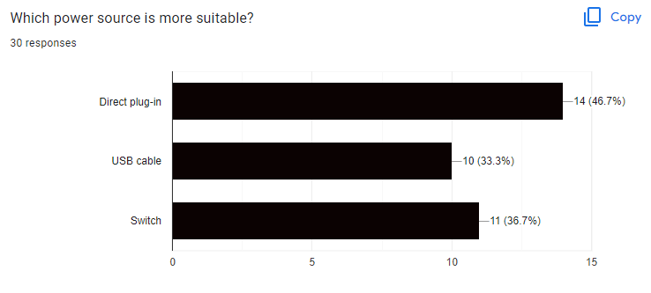

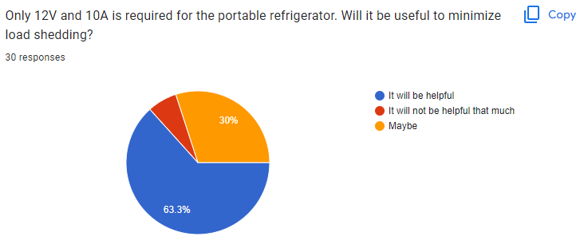

## Project Objective:

The major purpose of this project is to build a portable freezer using an Arduino UNO R3, a small servo SG90, and a thermoelectric cooler. This is a hardware-based project. The goal of a portable freezer is to make it easy to transport any place, to keep food and beverages pristine and cool, and to provide an intelligent perspective on life by raising the standard. People prefer to stay hydrated and consume foods free from any sort of contamination as any meal, but it's difficult to do so outside. So, the goal of our project is to make it easier for individuals to acquire chilled and fresh food at any time and at any location being compact enough to be transported anywhere.

## A brief outline of the report:

The introduction to a refrigerator system is included in the first section. The definition, short description, and goal of the project are all provided here. The current state of the smart refrigerator, current research, and some vital information collected from many research articles are included in the literature review. The methods utilized in this project are given in the methodology section. How the component is connected, how the component was selected, how those components perform, and a concise description of the essential component are all included. In the result, part simulation analysis of different states of the project and hardware implementation of the project is included. In the conclusion section, a short description of the project is included.

# Literature Review

The next SDG might be cooling for all in the age of industrial revolution 4.0 and sustainability development growth estimations. At the pace that global temperatures and humidity are rising in the summer, it may sound speculative at the moment, but any living species will eventually need to consume more cool refreshing liquids to stay alive and hydrated enough to relieve their dry throats. As a result, the portable freezer is useful in any outdoor, humid climate.

Eddy Erham [1] stated that according to the experimental findings, the suggested control system was able to maintain the intended temperature with a steady-state inaccuracy of around 0.044°C. Additionally, in a steady state, the refrigerator's control system was able to save roughly 30% of energy and was essentially independent of the amount of cooling load.

Norhazwani Abd Malek [2] focused on the creation and advancement of a small portable cooler that uses the Peltier impact to cool and preserve the nutrition of the human expressed breast milk (EBM) intact for use at a later time as well as the wellness of any toddler who consumes it within 24 hours at a temperature range between 4°C and 15°C. It was created to avoid the monotony of utilizing cooler boxes or bags, which call for ice packs that must be frozen repeatedly.

N. A. Asyiqin [3] focused on how to create a fridge product system that would offer ease to the consumer. The method was created using a thermoelectric Peltier and an Arduino UNO to enhance currently available goods. The thermoelectric, also known as Peltier coolant, used the Peltier effect to transfer heat from one side to the other when a current was delivered across it. This device normally produced a heat differential of between 40 and 70 degrees Celsius.

In the research work done by D. Suman [4], their Peltier refrigerator worked better and lasts longer when it had water pockets, and the temperature could be varied to maintain the objects at the right temperature by adjusting the input voltage and current. Finally, the lowest temperature, 2°c, was recorded.

Shubham Sonawane [5] in their research stated that the present refrigerator system produces Freon, ammonia, and other refrigerant having a cooling effect. Although employing these refrigerants can increase output, one of the biggest drawbacks is that they cause dangerous gas emissions and global warming. The Peltier effect and environmental protection can be used to solve these problems.

# Methodology & Modeling

For the proper thermoelectric module, design selection for the specific application requires an evaluation of the total system in which refrigeration is used. As for general applications, it can be done by using standard module configurations, while in many cases, the need for special design is mandatory to meet electrical, mechanical, and many other requirements. The basic design of the refrigerator is based on the Vapor Compression System

## Working Principle of the project

The working principle of the project is to cool down the objects that will be kept inside the fridge. That’s the basic work principle of every fridge but what most fridge lacks is the automated system that our system was formed on. An embedded system was formed which instructs the other components resulting in the fridge’s door opening whenever an object or a person is close to the sensor which is linked to the embedded system. These instructions are given by the users through a widely accepted user-friendly C++ programming language in the Arduino IDE development tool. There’s a digital thermometer to observe the temperature.

## Description of the components

* **Arduino UNO R3:** An ATmega328-based microcontroller board popularly called the Arduino Uno R3 board has 14 digital I/O pins, an ICSP header, a power connector, 6 analog I/O pins, a ceramic resonator operating at 16 MHz, a USB port, and 14 digital I/O pins. By connecting this board to the computer and with the use of commands like pinMode(), digitalWrite(), and Digital Read, the 14 digital pins of the Arduino Uno may be utilized as input and output ().
* **Servo Motor (SG-90):** A tiny machine with an output shaft is called a servo motor. Sending the servo, a coded signal allows for precise angular positioning of this shaft.
* **TEC1-12715:** It is also called a thermoelectric cooler. Cooling is the primary use of the Peltier effect. The Peltier effect, however, may also be utilized to heat or regulate temperature. Any situation calls for a DC voltage.
* **Power Supply:** Using an input power transformer, a power supply steps down the voltage to the voltage needed by the load after converting the AC from the wall outlet to unregulated DC.
* **Fans:** As the name implies, a DC fan (12V) uses electromagnetic induction and DC voltage to transform electric energy into electromagnetic energy, mechanical energy, and eventually kinetic energy to whirl the fan blades.
* **Jumper cables:** Jumper cables, also known as booster cables or jump leads, are two insulated wires with enough capacity and alligator clips at either end to connect any piece of equipment to the same system voltage or a separate battery.
* **Ultrasonic distance sensor** **(HC-SR04):** It has non-contact measurement capabilities ranging from 2cm to 400cm with a range accuracy of up to 3mm. An ultrasonic transmitter, a receiver, and a control circuit are all included in each HC-SR04 module. The HC-SR04 has only four pins: VCC (Power), Trig (Trigger), Echo (Receive), and GND (Ground).
* **Heat sink:** A heat sink is a static heat exchanger that dissipates heat produced by an electrical or mechanical device away from the device and into a fluid medium, either wind or a liquid coolant. This allows the temperature of the device to be controlled.
* **Digital Thermometer:** A digital thermometer comes with an LCD where the temperature is shown. It is operated with a small button cell named AG13 SH 357A. At its tail side, there’s a small mercury rod that detects the temperature change.

## Implementation:

There are two parts to the implementation. Firstly, there’s the thermal cooler implementation involving a heat sink, TEC1-12715, CPU fan, connecting cables, and power supply. Proper insulation was also ensured for faster cooling. Secondly, the embedded system is implemented with components such as an Arduino Uno R3, an Ultrasonic distance sensor (HC-SR04), and a servo motor (SG-90). A digital thermometer was installed for temperature visibility. Whenever the temperature changes the thermometer displays the current temperature through its mercury rod.

In the thermal cooler, two fans a 3-inch big fan and a CPU fan) were used demanding 12V DC in total, Peltier (TEC1-12715), Thermal paste, and Heat Sinks. The bigger fan (3inch) was to cool down the Peltier. Peltier got cold in the front part and at the same time, it got really hot in the back part. To cool down the hot temperature, a thermal paste and a CPU fan (which had a built-in heat sink with it) were used. The other heat sink was placed at the front of the Peltier which consumed the cold temperature to deliver the cold air inside the airtight space and the smaller fan (1.5inch) was used to deliver that cold air inside. The demanded voltage was 12V and 15.57A but a power supply of 12V and 10A were provided for more stability. Providing more supply had the possibility of damaging the components.

On the other part of the entire system, Arduino Uno R3, an Ultrasonic distance sensor (HC-SR04), and a servo motor (SG-90) were used. The working principle of the ultrasonic distance sensor was to generate and receive waves just like a bat does. It was used to sense an object or a person so that the servo motor could be instructed to operate only if the sensor sensed someone in front of the sensor. A conditional command was introduced in the program for the sensor so that when the user was at a fixed distance from the ultrasonic sensor, the servo motor was instructed to move from an angle of 0 degrees to 180 degrees. The servo motor was found to be weaker than most other motors because it could not rotate more than 180 degrees. It had a built-in block that prevented the motor to rotate more than 180 degrees. Since it lacked proper metal plating for the base, there’s a mechanism that was designed where a 1-liter plastic water bottle was used to make its base heavier. Then a clip was attached at the top of the motor which did hold it during rotation This mechanism allowed the motor to become more firm in place and the heavy base helped it to operate accordingly. The ultrasonic distance sensor was connected to pin 10 (Digital Pin), 11(PWM), and the Servo motor in PIN 3. Another reason for using a servo motor was, to function the system using one program.

## Experimental setup:

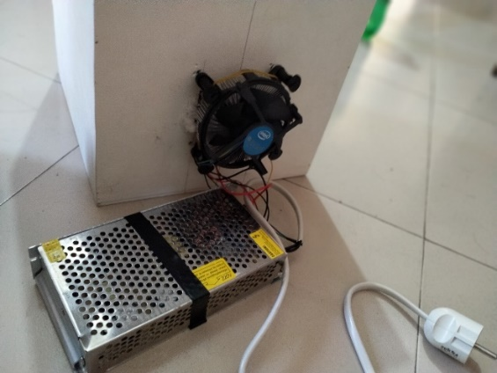

Figure 1: Experimental setup of the proposed system (thermal cooler)

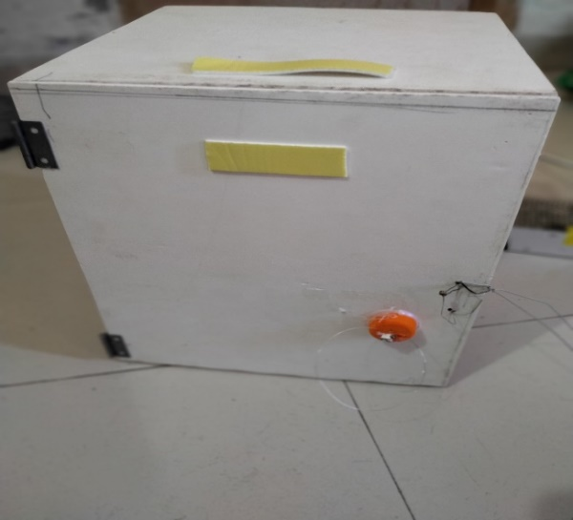

Figure 2: Experimental setup of the proposed system (outside view of the freezer)

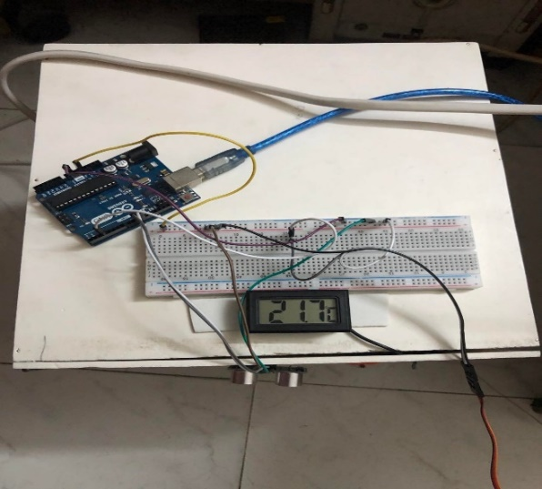

Figure 3: Experimental setup of the proposed system (with a digital thermometer)

# Cost Analysis

| PRODUCT NAME | **QUANTITY** | PRICE (in BDT) |
| --- | --- | --- |
| E-star Power supplier | 1 | 590 |
| Servo motor | 1 | 120 |
| Arduino UNO R3 | 1 | 1070 |
| TEC1-12715 | 1 | 300 |
| Jumper wires | 3 set | 180 |
| Fan | 4 | 720 |
| Socket | 1 | 50 |
| Wire Copper | 1 | 30 |
| Soldering lead | 1 | 50 |
| Soldering Iron | 1 | 670 |
| Breadboard | 1 | 225 |
| Digital Thermometer | 1 | 262 |
| Ultrasonic Sonar Sensor | 1 | 120 |
| RFID-RC522 | 1 | 160 |
| Fridge body | 1 | 600 |
| Heat Sink | 3 | 270 |
| 5V power supply | 1 | 220 |
| Battery Holders | 6 | 346 |
| 1.5V AA Battery | 6 | 120 |
| Switch | 3 | 60 |
| Glue Gun | 1 | 120 |
| Glue Stick | 3pcs | 30 |
| Anti-Cutter | 1 | 80 |
| Clips | 2pcs | 40 |
| **Total** |  | **6433** |

# Result & Analysis

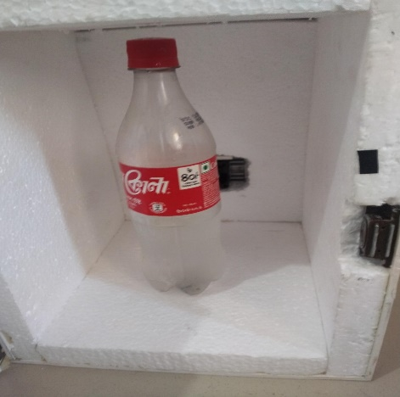

Figure 4: Experimental result (with a mini plastic bottle containing water)

On our first attempt, the freezer worked well, taking 5 hours to reach a temperature of 20 degrees Fahrenheit and providing a satisfactory outcome. It reduced to 10 degrees in the next 5 hours. It reached 5 degrees in the next 5 hours, thus the heat sink was covered with water.

## Block Diagram & Implemented snapshot

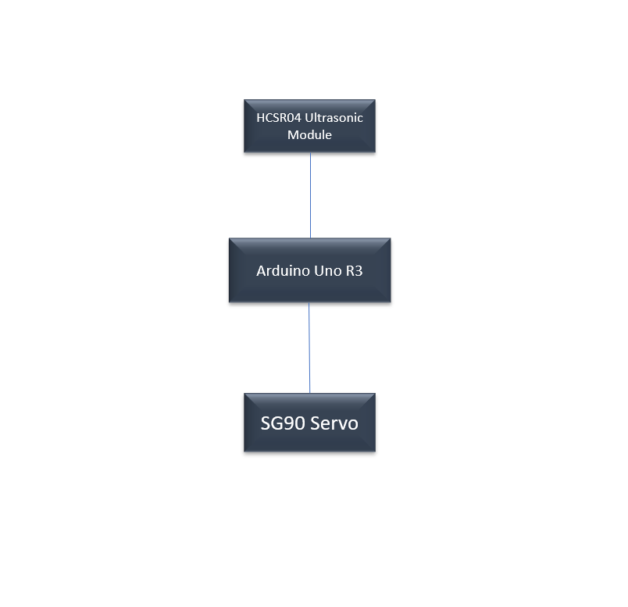

Figure 5: Block Diagram of automated door system

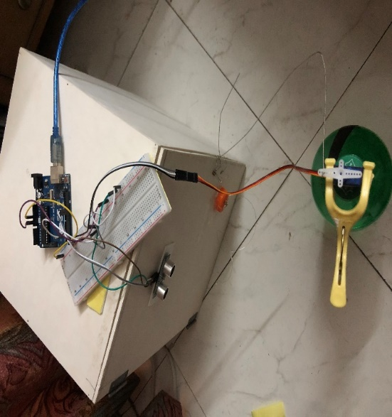

Figure 6: Experimental setup along with automated door system

## Measured Response:

|  |  |
| --- | --- |
| **Time slot (in hours)** | **Temperature (in degree Celsius)** |
| 0 | 20 |
| 2.5 | 17.5 |
| 5 | 15 |
| 7.5 | 12.5 |
| 10 | 10 |
| 12.5 | 7.5 |
| 15 | 5 |

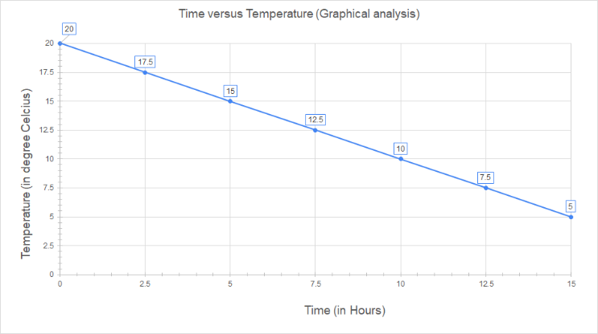

Figure 7: Graphical representation of cooling effect based on the data table

# Limitations

This project has several restrictions. The user cannot control the temperature. Another shortcoming of this system was the inability to remotely operate the refrigerator. Furthermore, it took a fair amount of time to cool down from the ambient temperature.

# Conclusion and Future Endeavors

Whilst operating on the venture, the task of fabricating a mini-fridge became quite exciting to perform the targets which were set very practically creating a refrigeration framework primarily utilized to maintain foods and beverages cool while traveling or doing outdoors. The Peltier effect and vapor compression impact were studied for developing, implementing, and checking the performance evaluation of the proposed embedded system. In the future, a feature of monitoring and controlling the temperature can be implemented (using a display module along with a temperature sensor). Another initiative can be to modify the program with the necessary commands to enable user authorizations to access the portable freezer. Furthermore, reducing the duration of freezing can be kept into consideration.

# Acknowledgment

Initially, we would like to express our gratitude to our instructor and supervisor Ms.Tahseen Asma Meem, for motivating us to continue working on this project. Finally, we would like to express our appreciation to every co-author, who contributed to this initiative.

# References

1. Erham, E., Markus, Surjanto, A. and Rukmana, J., (2018). Design of a new PID controller based on Arduino Uno R3 with application to the household refrigerator. MATEC Web of Conferences, 154, p.01044.
2. Norhazwani Abd Malek, Siti Zulaika Osman, Nurhusna Mohamad Ehsan, Nurzanariah Roslan, Mohd Fakhri Rosli., (2018). Design and Development of Mini Portable Cooler for Breastmilk Storage. International Journal of Engineering & Technology 7(4):569-572
3. N. A. Asyiqin, M. K. Fadzly, and T. Amarul., (2019). Thermoelectric portable mini fridge using Arduino Uno temperature control. AIP Conference Proceedings 2129, 020145 (2019)
4. D. Suman, P. H. P. Siva Hari Prasad, K.N.V. S Niranjan, K. Akhilesh, K. Jagadeesh Narayana Kumar. (2020). Design and Fabrication of Thermoelectric Refrigerator using Peltier Module. 2020 JETIR March 2020, Volume 7, Issue 3.
5. Sonawane, Shubham & Bari, Ujwala & Kulkarni, Mandar & Patil, Tushar. (2022). Design, Fabrication, and Testing of Refrigerator System by Using Peltier Effect. International Journal of Advanced Research in Science, Communication, and Technology. 31-34. 10.48175/IJARSCT-5642.